Active Directory Lab 07
Configuring and Testing DNS in Windows Server
Objective
The objective of this lab was to understand the role of the Domain Name System (DNS) in an Active Directory environment. The lab involved creating a new Host (A) record, verifying forward and reverse DNS name resolution, and managing the DNS cache using command-line tools. This exercise demonstrated how DNS enables reliable communication between clients and servers within a Windows domain.

Lab Environment
Component | Details
Operating System | Windows Server (Domain Controller)
Client Machine | Windows 11
Virtualization | VMware Workstation / VirtualBox
Domain | mydomain.com
Tool Used | DNS Manager, Command Prompt

Step 1: Opening DNS Manager
The DNS Manager console was opened from Server Manager on the Domain Controller. The DNS server hosting the mydomain.com zone was accessed to manage DNS records used by the Active Directory environment.
Result
The DNS Manager console opened successfully, displaying the configured DNS server and its available DNS zones.
Screenshot 1: DNS Manager Console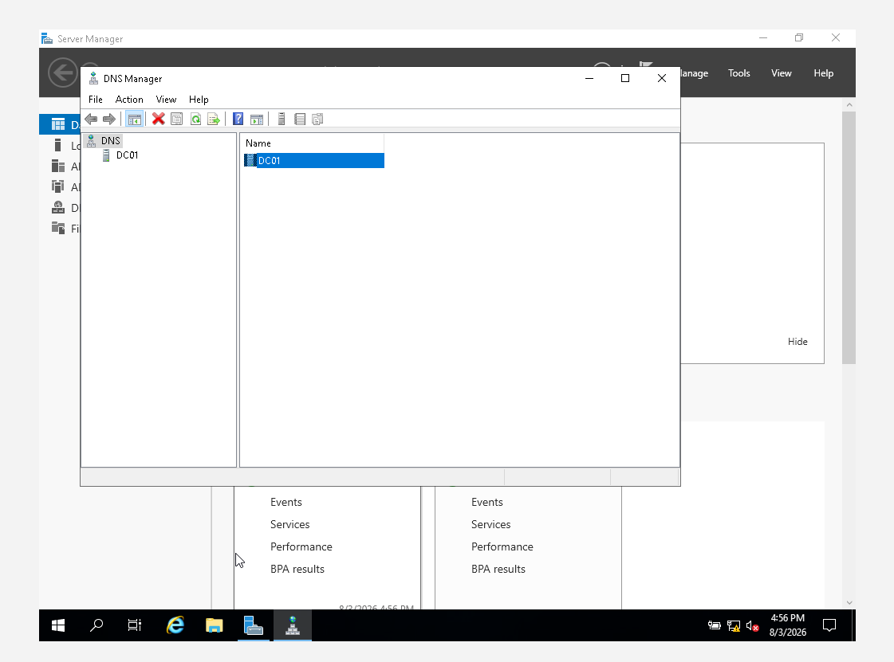

Step 2: Exploring the Forward Lookup Zone
The Forward Lookup Zones section was expanded, and the mydomain.com zone was selected. Existing DNS records were reviewed, including the A record for the Domain Controller and the Name Server (NS) records responsible for handling DNS queries within the domain.
This step provided an overview of the existing DNS infrastructure supporting the Active Directory environment.
Result
The Forward Lookup Zone was successfully explored, and the existing DNS records were verified.
Screenshot 2: Forward Lookup Zone Records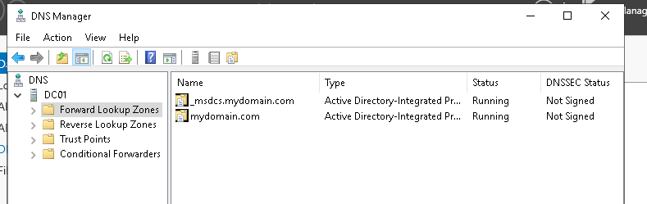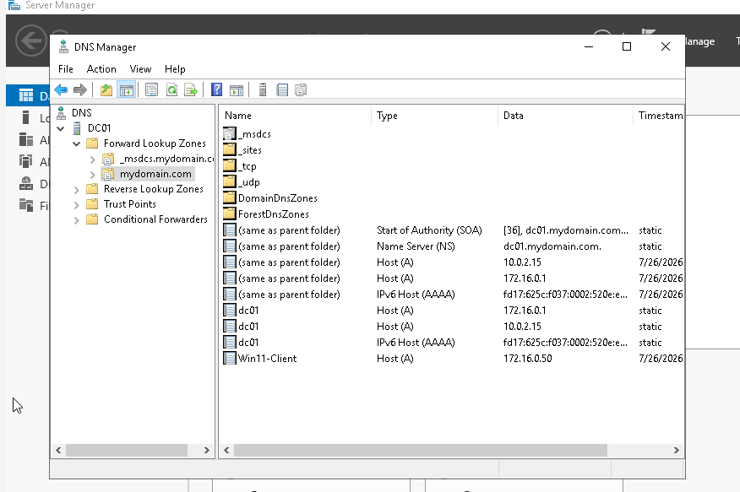

Step 3: Creating a New Host (A) Record
A new Host (A) record named test was created within the mydomain.com forward lookup zone. The hostname was mapped to the IP address 172.16.0.1, which corresponds to the Domain Controller. During creation, the option to automatically generate the corresponding Pointer (PTR) record was enabled.
This configuration allows the hostname test.mydomain.com to resolve to the specified IP address while also supporting reverse DNS lookups.
Result
The new A record and its associated PTR record were successfully created.
Screenshot 3: New Host (A) Record Created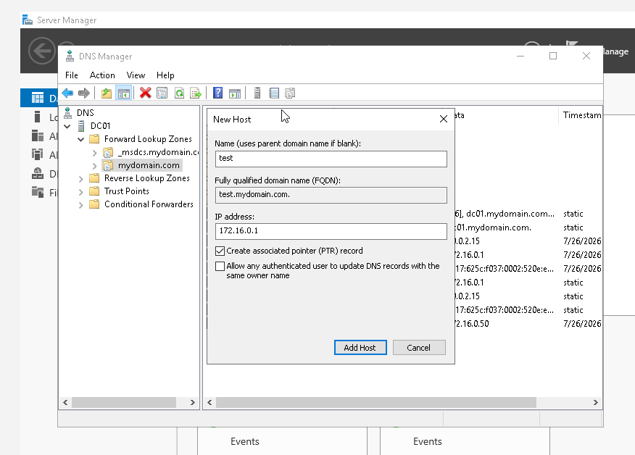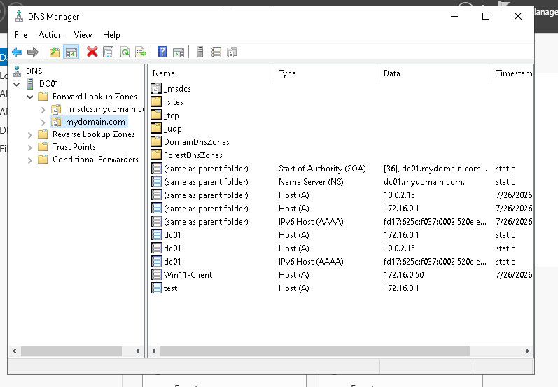

Step 4: Verifying Forward DNS Resolution
The Windows 11 client machine was used to verify DNS functionality using the nslookup command. DNS queries were performed for both test.mydomain.com and mydomain.com.
The hostname successfully resolved to the IP address 172.16.0.1, confirming that the newly created DNS record was functioning correctly.
Result
Forward DNS name resolution was successfully verified from the client machine.
Screenshot 4: Forward DNS Resolution Using nslookup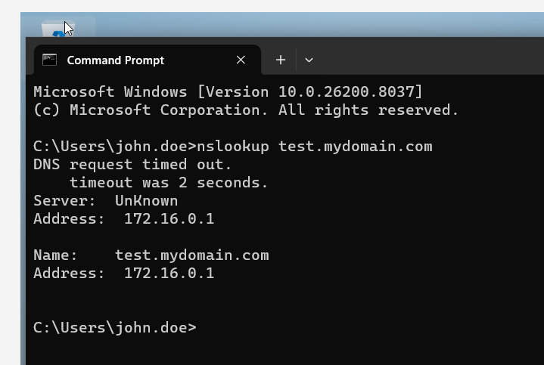

Step 5: Managing the DNS Cache
The local DNS cache on the client machine was examined using the ipconfig /displaydns command. The DNS cache was then cleared using ipconfig /flushdns, and the cache contents were viewed again to confirm that cached DNS entries had been removed.
This exercise demonstrated how cached DNS records can be viewed and refreshed to ensure that clients retrieve the latest DNS information.
Result
The DNS cache was successfully displayed, cleared, and verified after the cache flush operation.
Screenshot 5: DNS Cache Management Commands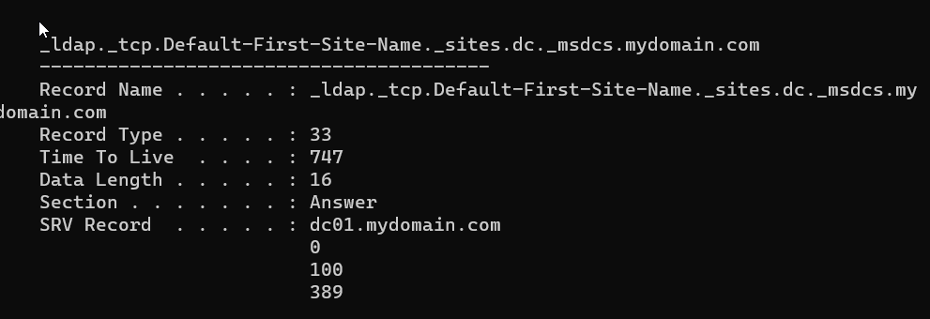 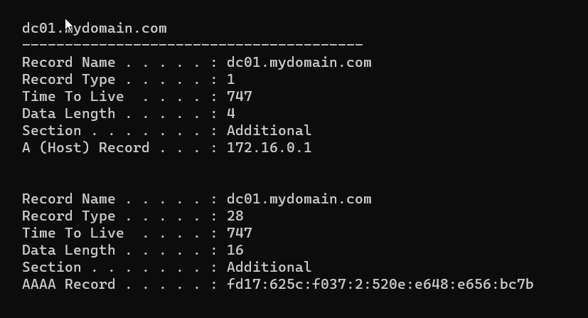 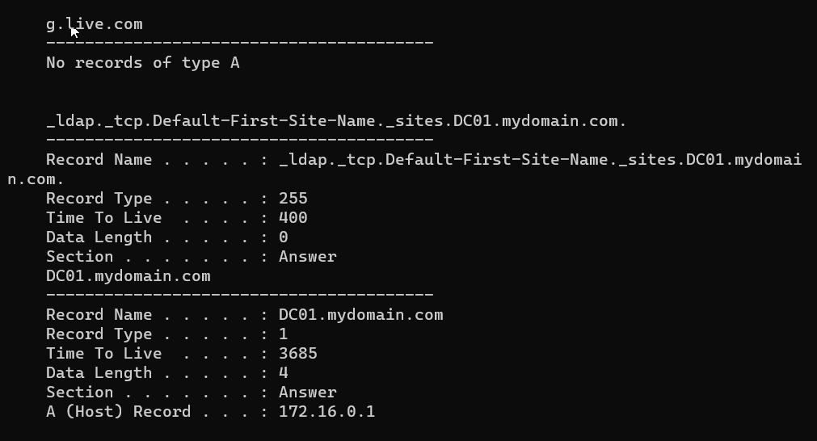 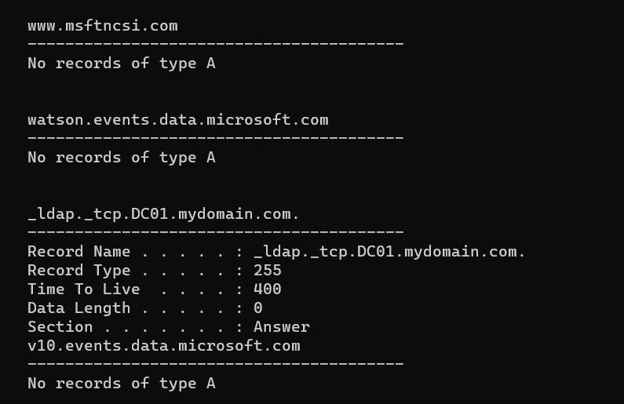
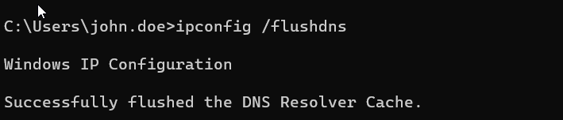

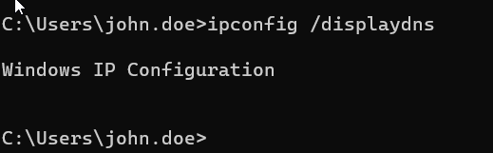

Step 6: Verifying Reverse DNS Resolution
A reverse DNS lookup was performed using the nslookup command with the IP address 172.16.0.1. The query successfully returned the hostname test.mydomain.com, confirming that the automatically generated PTR record was functioning correctly.
This verified that reverse name resolution was properly configured within the DNS server.
Result
Reverse DNS resolution was successfully verified using the configured PTR record.
Screenshot 6: Reverse DNS Lookup Result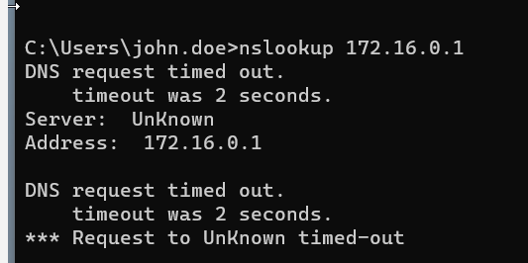

Conclusion
This lab provided practical experience in configuring and managing the Domain Name System (DNS) within an Active Directory environment. The Forward Lookup Zone was explored, and a new Host (A) record was successfully created along with its corresponding PTR record. DNS functionality was validated through forward and reverse name resolution using the nslookup utility. Additionally, DNS cache management was performed using ipconfig commands to demonstrate how cached records can be viewed and refreshed. Overall, this lab reinforced the critical role of DNS in supporting Active Directory services and ensuring reliable name resolution across the network.

